

Belmont City College
Part 1: /15

YEAR 12 PHYSICS

PRACTICAL ASSESSMENT, PART 1

CIRCULAR MOTION

NAME: ______________________________

Time allowed: 35 mins

A talented physics student conducted an experiment investigating circular motion. The apparatus is shown below.

The stopper was whirled in a circle and the radius of the circle was kept at a constant value of
0.600 m.

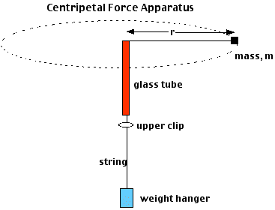
Mass supplying the centripetal force (F_{c})
alligator clip or sticky tape
stopper (mass = m)

The results obtained are shown in the table on the next page:
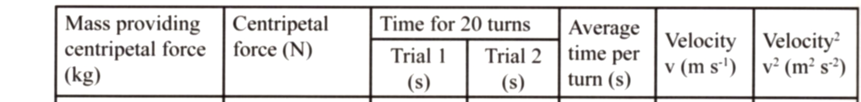

0.200 14.9 15.2

0.250 14.2 13.1

0.300 12.9 11.7

0.400 10.8 10.3

0.450 10.1 10.2

1. Complete the table of results above. (2 marks)

2. On the graph paper provided, plot the data of centripetal force versus velocity squared.
(3 marks)

3. Use the graph paper provided to determine the mass of the rubber stopper (show all working below and clearly explain any data taken from the graph or table) (5 marks)

4. In reality, the fishing line will not rotate in a perfectly horizontal circle.

Glass tube

Stopper

Fishing line

Masses

a) Draw fully labeled arrows to represent all forces on the stopper. (2)

b) What force or component of force balances the weight of the stopper? (1)

c) In this experiment, it was assumed that the tension in the fishing line is equal to the centripetal force. If the fishing line makes an angle to the horizontal as shown above, this will not be true. If the angle between the string and the horizontal is 5°, use simple trigonometry to show that the difference between T and Fc is still less than 1% (2)

